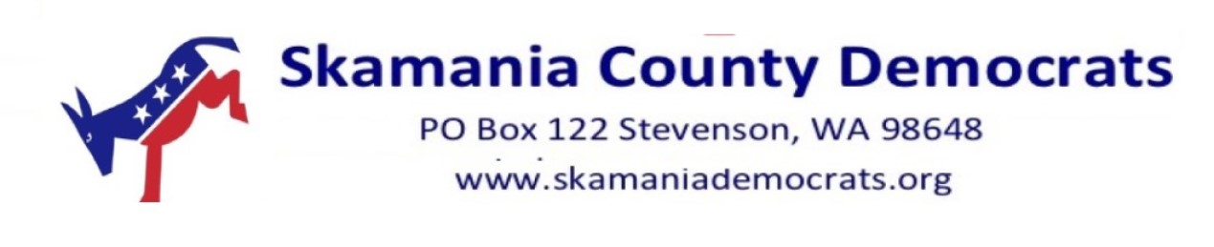

Benefits of Membership
with Skamania County Democrats

You join the effort to support Democratic Principle and get involved

Free Bumper Sticker
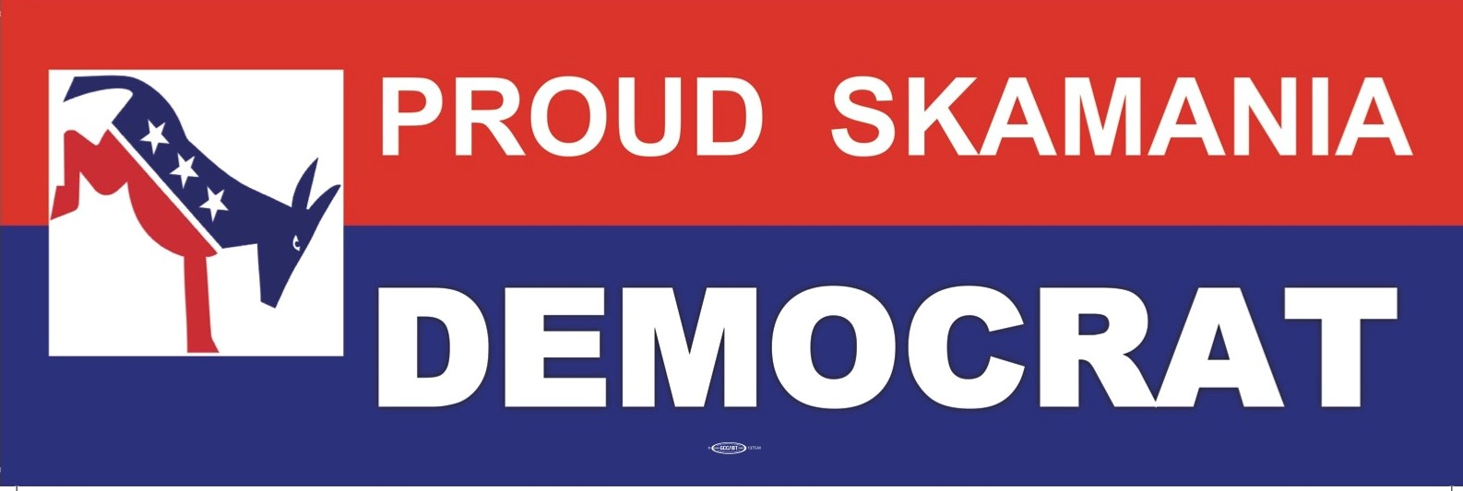

Addition to our Support your Local Democratic Businesses list

